Zimbabwe

## Population Data

The data set shows the political stability estimate of the country each year.

## # A tibble: 23 x 5  
## country iso3c date population popCategory5  
## <chr> <chr> <dbl> <dbl> <chr>   
## 1 Zimbabwe ZWE 1996 11541217 small   
## 2 Zimbabwe ZWE 1997 11653242 small   
## 3 Zimbabwe ZWE 1998 11747072 small   
## 4 Zimbabwe ZWE 1999 11822719 small   
## 5 Zimbabwe ZWE 2000 11881477 small   
## 6 Zimbabwe ZWE 2001 11923914 small   
## 7 Zimbabwe ZWE 2002 11954290 small   
## 8 Zimbabwe ZWE 2003 11982224 small   
## 9 Zimbabwe ZWE 2004 12019912 small   
## 10 Zimbabwe ZWE 2005 12076699 small   
## 11 Zimbabwe ZWE 2006 12155491 small   
## 12 Zimbabwe ZWE 2007 12255922 small   
## 13 Zimbabwe ZWE 2008 12379549 small   
## 14 Zimbabwe ZWE 2009 12526968 small   
## 15 Zimbabwe ZWE 2010 12697723 small   
## 16 Zimbabwe ZWE 2011 12894316 small   
## 17 Zimbabwe ZWE 2012 13115131 small   
## 18 Zimbabwe ZWE 2013 13350356 small   
## 19 Zimbabwe ZWE 2014 13586681 small   
## 20 Zimbabwe ZWE 2015 13814629 small   
## 21 Zimbabwe ZWE 2016 14030390 small   
## 22 Zimbabwe ZWE 2017 14236745 small   
## 23 Zimbabwe ZWE 2018 14439018 small

# Population growth data

## # A tibble: 23 x 5  
## country iso3c date popGrowth popGrowthCat5   
## <chr> <chr> <dbl> <dbl> <chr>   
## 1 Zimbabwe ZWE 1996 1.14 slow growth rate   
## 2 Zimbabwe ZWE 1997 0.966 slow growth rate   
## 3 Zimbabwe ZWE 1998 0.802 slow growth rate   
## 4 Zimbabwe ZWE 1999 0.642 slow growth rate   
## 5 Zimbabwe ZWE 2000 0.496 slow growth rate   
## 6 Zimbabwe ZWE 2001 0.357 slow growth rate   
## 7 Zimbabwe ZWE 2002 0.254 slow growth rate   
## 8 Zimbabwe ZWE 2003 0.233 slow growth rate   
## 9 Zimbabwe ZWE 2004 0.314 slow growth rate   
## 10 Zimbabwe ZWE 2005 0.471 slow growth rate   
## 11 Zimbabwe ZWE 2006 0.650 slow growth rate   
## 12 Zimbabwe ZWE 2007 0.823 slow growth rate   
## 13 Zimbabwe ZWE 2008 1.00 slow growth rate   
## 14 Zimbabwe ZWE 2009 1.18 slow growth rate   
## 15 Zimbabwe ZWE 2010 1.35 slow growth rate   
## 16 Zimbabwe ZWE 2011 1.54 moderate growth rate  
## 17 Zimbabwe ZWE 2012 1.70 moderate growth rate  
## 18 Zimbabwe ZWE 2013 1.78 moderate growth rate  
## 19 Zimbabwe ZWE 2014 1.75 moderate growth rate  
## 20 Zimbabwe ZWE 2015 1.66 moderate growth rate  
## 21 Zimbabwe ZWE 2016 1.55 moderate growth rate  
## 22 Zimbabwe ZWE 2017 1.46 slow growth rate   
## 23 Zimbabwe ZWE 2018 1.41 slow growth rate

## Population trend

The plot shows the population trend of the country.

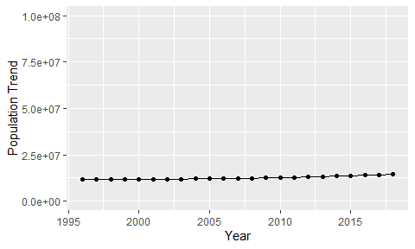

Political Stability Trend

# Population growth trend

The plot shows the population growth rate trend of the country.

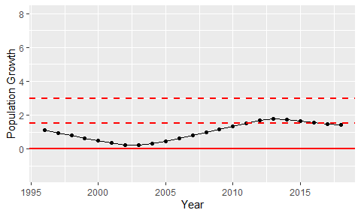

Population Growth Trend